Fwd: Disk management - assignment

1)Create 2 primary partitions of 3 GB each
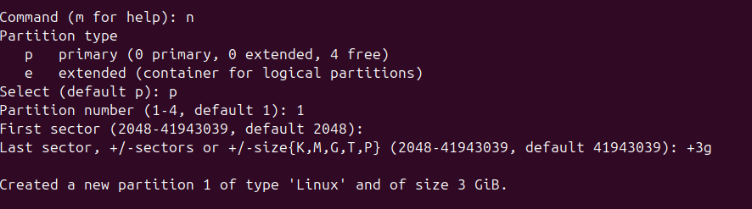

b) Create 2 logical partitions of 6 GB each
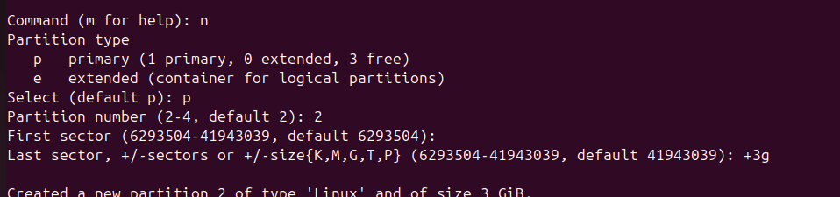
c) Format all 4 partitions and create ext4 filesystem on that
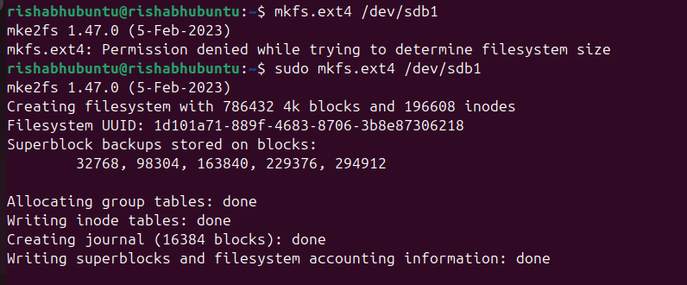
d) Create 4 folders inside root ( / ) folder name it as Data1, Data2, Data3, Data4
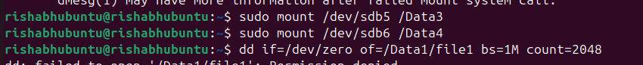
f) Create empty file inside each folders of size 2 GB, 2GB, 4 GB and 4 GB respectively using command - dd - "convert and copy a file"
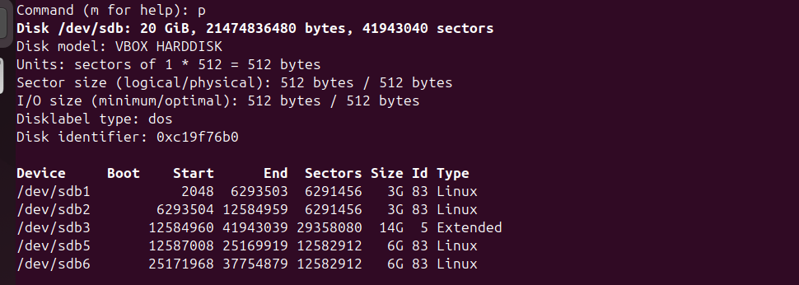
g) Go inside /Data1 and run command - while(true); do sleep 5s; done , do ctrl-z

h) Check disk utilization of each mount point
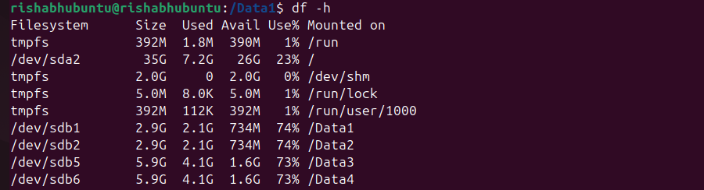
i) Unmount all partitions /Data1, /Data2, /Data3 and /Data4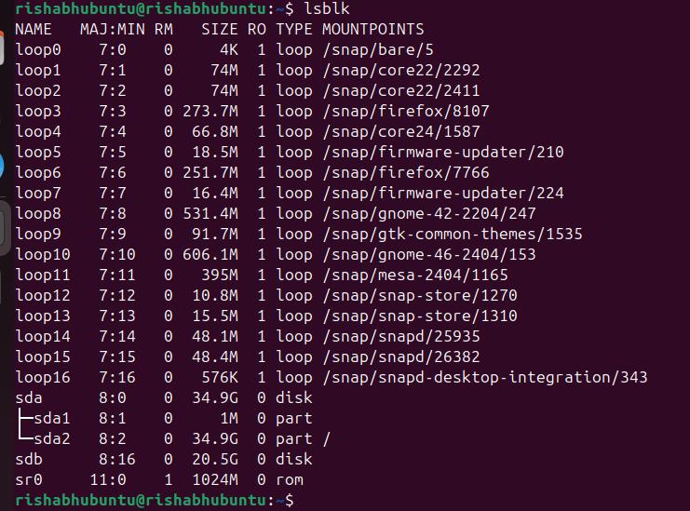

Explanation:-
The goal of this task is to manage a newly attached disk by creating partitions, formatting them, mounting them to directories, performing file operations, monitoring disk usage, and ensuring persistence after system reboot.

Step 1: Disk Verification
After attaching a new disk to the system, it is first verified to ensure that the operating system detects it properly. The disk appears as a new device (for example, a secondary disk separate from the main system disk).

Step 2: Partition Creation
The disk is divided into multiple sections called partitions.
- Two primary partitions of 3 GB each are created.
- One extended partition is created to hold logical partitions (since a disk can have a limited number of primary partitions).
- Inside the extended partition, two logical partitions of 6 GB each are created.
This structure allows efficient utilization of disk space while following standard partitioning rules.

Step 3: Filesystem Creation
Each partition is then formatted with the ext4 filesystem.
Formatting prepares the partition for storing data by organizing it into a structure that the operating system can read and write.

Step 4: Directory Creation
Four directories are created inside the root directory:
- /Data1
- /Data2
- /Data3
- /Data4
These directories act as mount points where each partition will be attached.

Step 5: Mounting Partitions
Each formatted partition is mounted to one of the created directories:
- First primary partition → /Data1
- Second primary partition → /Data2
- First logical partition → /Data3
- Second logical partition → /Data4
Mounting makes the partition accessible as part of the system’s directory structure.

Step 6: File Creation Using dd Concept
Files of specific sizes are created inside each mounted directory to simulate disk usage:
- 2 GB file in /Data1
- 2 GB file in /Data2
- 4 GB file in /Data3
- 4 GB file in /Data4
This demonstrates how data occupies space within each partition.

Step 7: Background Process Demonstration
A continuous loop process is started inside one of the mounted directories (/Data1) and then paused.
This step demonstrates:
- Process execution in Linux
- How processes can be suspended and managed

Step 8: Disk Utilization Check
Disk usage is checked to observe:
- Total size of each partition
- Used space (due to created files)
- Available free space
This helps in understanding storage consumption and allocation.

Step 9: Unmounting Partitions
All partitions are unmounted from their respective directories.
Unmounting safely detaches the partition from the system, ensuring no data corruption occurs.

Step 10: Automatic Mount Configuration
To ensure that partitions are automatically mounted after a system reboot, entries are added to the system configuration file responsible for filesystem mounting.
This ensures:
- No need for manual mounting after restart
- Persistent availability of all partitions

Step 11: Verification After Reboot
After rebooting the system, it is verified that:
- All partitions are automatically mounted
- Data inside them is intact
- System recognizes all mount points correctly

